

**WEB TECHNOLOGIES**

**LAB-2**

**NAME:**

SUDANA SHASHI KIRAN

**REDG NUMBER:**

21BCE8644

**PROFFESOR:**

# DR. SHAIK KAREEMULLA

**Create a html web page to display your resume in tabular format using several HTML Tags.**

Firstly I created the resume and included all the required folders with connection as mentioned below :

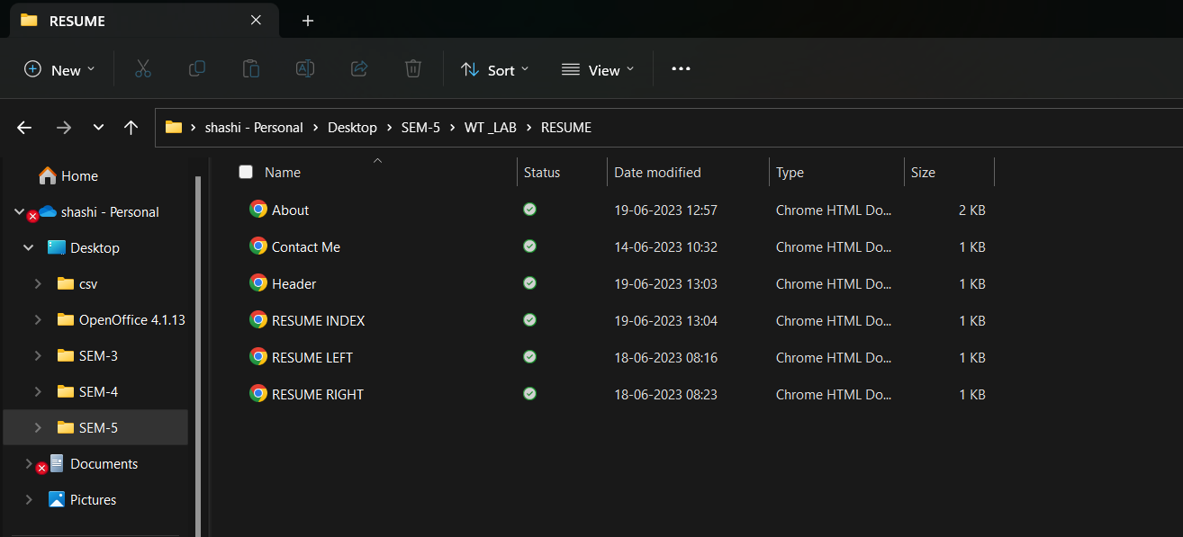

**In the resume index the whole consists of as mentioned below**

**Code:**

<!DOCTYPE HTML>

<html>

<head>

<title> Index Page </title>

<style>

body {background-color:#ccffff;}

header {color: black;

font-size: 180% }

p {color: red;}

</style>

</head>

<iframe name= "header" height ="200" width="100%" src="Header.html"></iframe>

<iframe name= "left" height ="500" width="18%"src="RESUME LEFT.html"></iframe>

<iframe name= "right" height ="500" width="80%"src="RESUME RIGHT.html"></iframe>

</body>

</html>

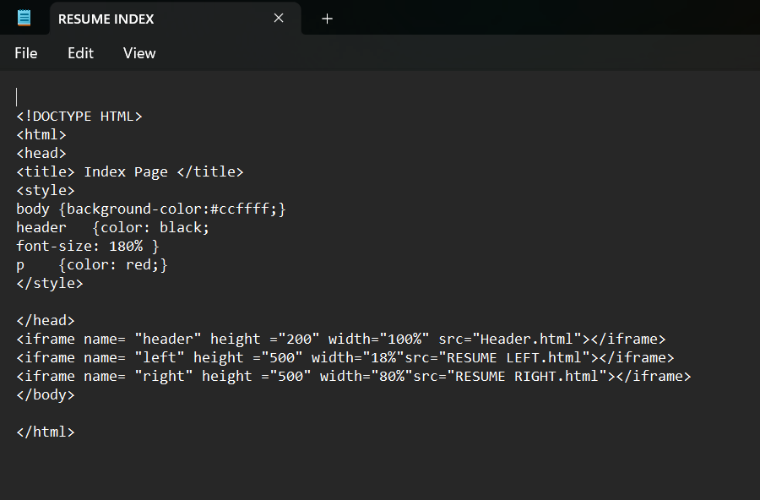

**Screenshot:**

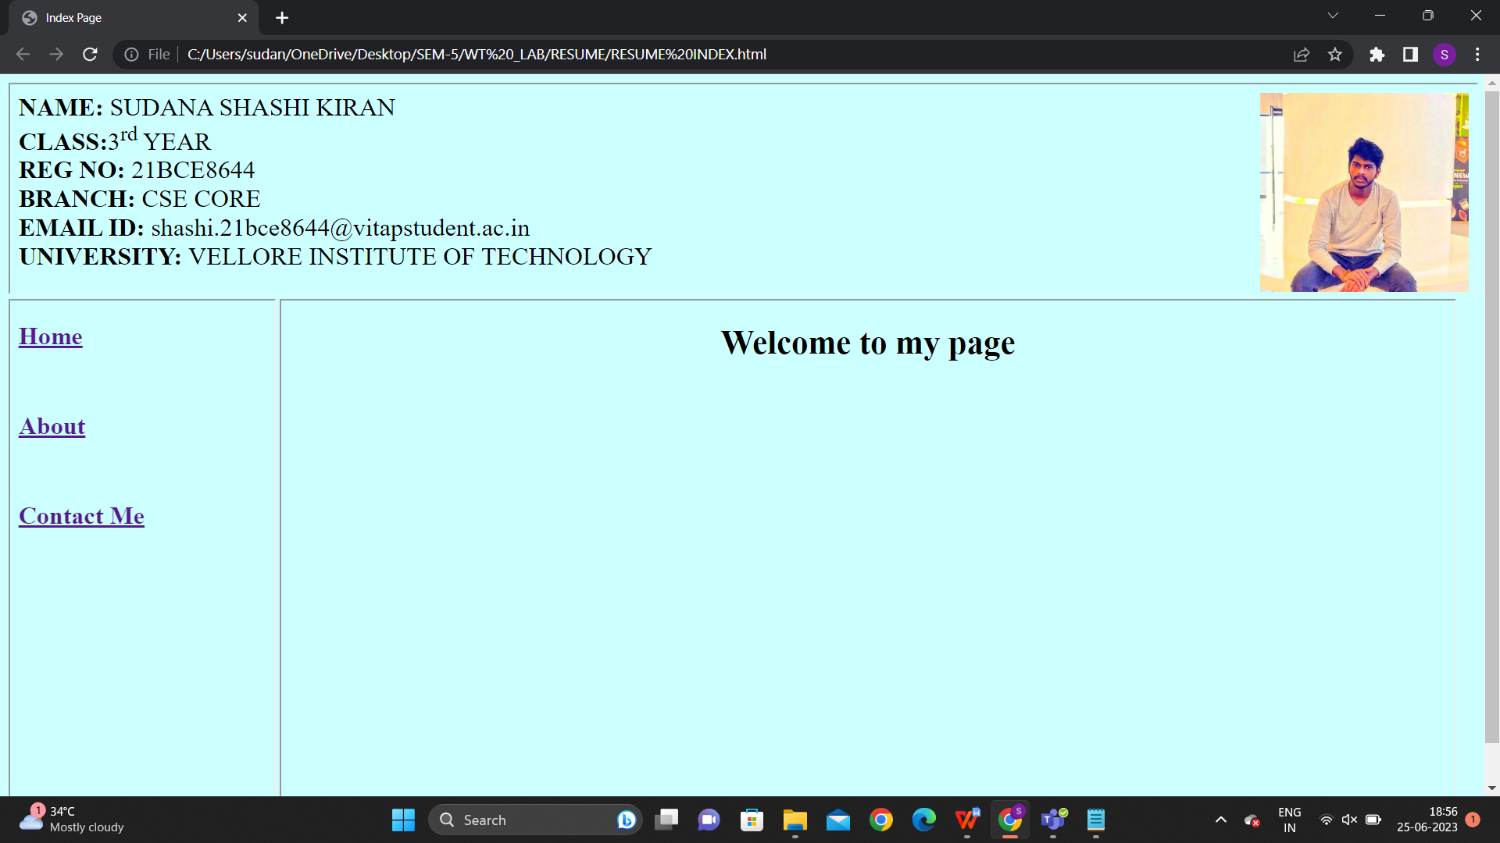

**There was a header , left and right frames I connected with**

**Header.html**

**Resume left**

**Resume right**

**The code and screenshot for header file**

**Only for Resume header :**

**Code:**

<!DOCTYPE HTML>

<html>

<head>

<title> Header </title>

<style>

body {background-color:#ccffff;}

header {color: black;

font-size: 150% }

p {color: red;}

</style>

</head>

<body>

<img src="C:\Users\sudan\OneDrive\Pictures\Screenshots\Screenshot 2023-05-14 125520.png" alt="profilepic" width="200" height="191" style="float:right";>

<header>

<strong>NAME:</strong> SUDANA SHASHI KIRAN<br>

<strong>CLASS:</strong>3<sup>rd</sup> YEAR<br>

<strong>REG NO:</strong> 21BCE8644<br>

<strong>BRANCH:</strong> CSE CORE<br>

<strong>EMAIL ID: </strong>shashi.21bce8644@vitapstudent.ac.in<br>

<strong>UNIVERSITY: </strong>VELLORE INSTITUTE OF TECHNOLOGY<br>

</header>

<br><br>NAME : SUDANA SHASHI KIRAN <br>

REGISTRATION NUMBER: 21BCE8644

</body>

</head>

**Screenshot:**

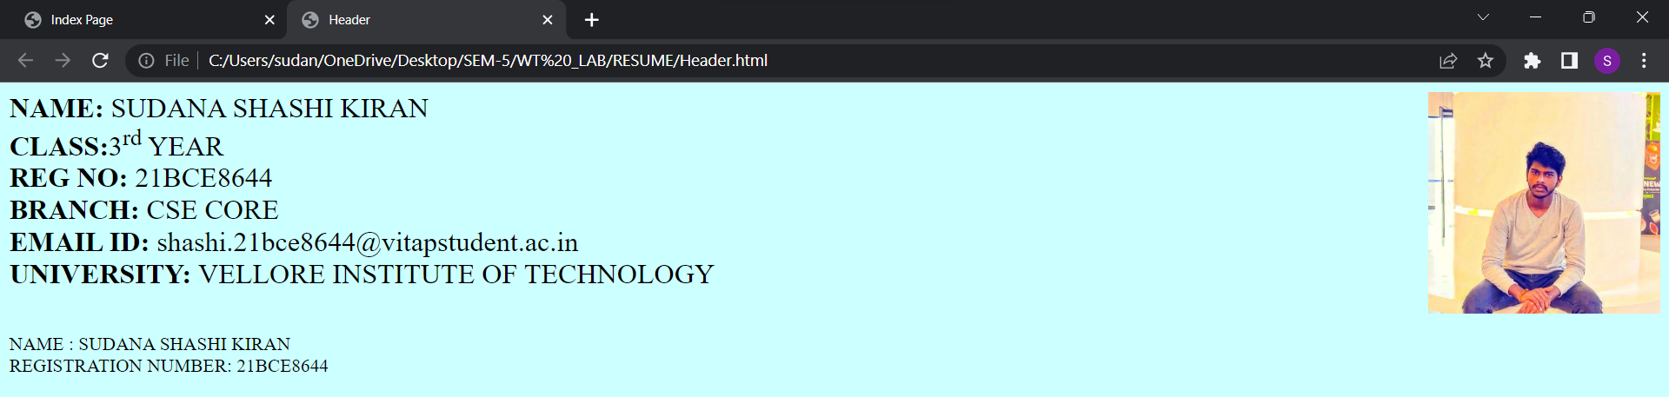

**Only for Resume left frame**

**Code :**

<!DOCTYPE HTML>

<html>

<head>

<title> Left Page </title>

</head>

<body>

<a href="RESUME RIGHT.html"target="right">

<h2>Home</h2>

</a><br>

<a href="About.html"target="right">

<h2>About</h2>

</a><br>

<a href="Contact Me.html"target="right">

<h2>Contact Me</h2>

</a><br>

<br><br>NAME : SUDANA SHASHI KIRAN <br>

REGISTRATION NUMBER: 21BCE8644

</body>

</html>

**Screenshot:**

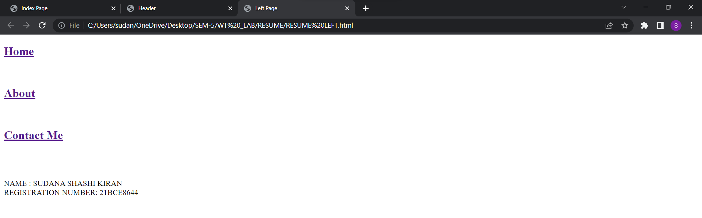

**Only for resume right frame :**

**Code:**

<!DOCTYPE HTML>

<html>

<head>

<title> Right Page </title>

<style>

body {background-color:#ccffff;}

header {color: black;

font:times new roman;

font-size: 400%

}

p {color: red;}

</style>

</head>

<body>

<center>

<h1> Welcome to my page </h1>

</center>

NAME : SUDANA SHASHI KIRAN <br>

REGISTRATION NUMBER: 21BCE8644

</body>

</html>

**Screenshot :**

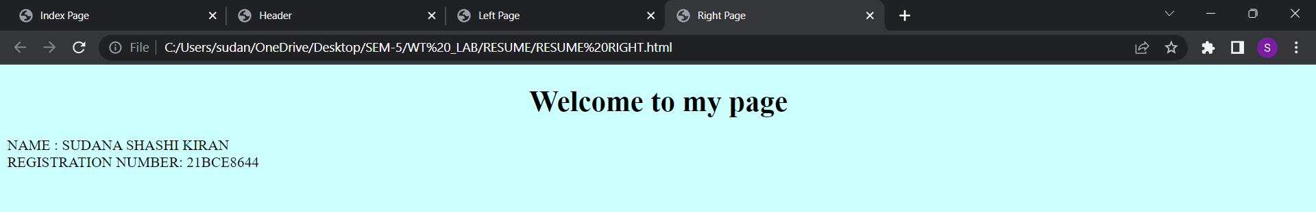

**HYPER LINKS :**

**Home**

**About**

**Contact me**

**Code for home page is sam as the default**

**As mentioned below :**

**Code:**

<!DOCTYPE HTML>

<html>

<head>

<title> Right Page </title>

<style>

body {background-color:#ccffff;}

header {color: black;

font:times new roman;

font-size: 400%

}

p {color: red;}

</style>

</head>

<body>

<center>

<h1> Welcome to my page </h1>

</center>

NAME : SUDANA SHASHI KIRAN <br>

REGISTRATION NUMBER: 21BCE8644

</body>

</html>

**Screenshot:**

When I click on the home botton

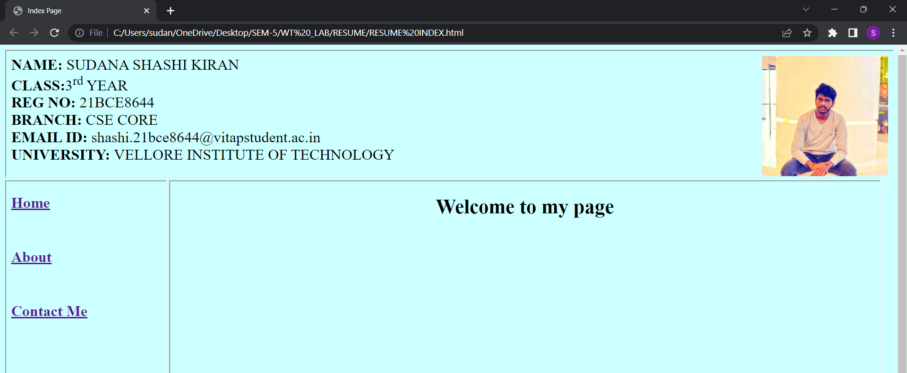

**Code and screenshot for about page :**

**Code:**

<html>

<head>

<title>About Page</title>

<style>

body {background-color:#ccffff;}

header {color: black;

font-size: 40% }

p {color: red;}

</style>

</head>

<style>

table, th, td {

border: 1px solid black;

border-collapse: collapse;

}

</style>

</head>

<body>

<p><b>Carrer Objective: </b></p> To get an opportunity where I can make the best of my potential and contribute to the organization's growth. Seeking a position in a company where I can launch my career and build a valuable skill set.

<br><br>

<p>

<b> Education: <br>

</p>

</b>

<table>

<tr>

<th>Qualification</th>

<th>School/College</th>

<th>Grade</th>

</tr>

<tr>

<td>SSC</td>

<td>Sri chaitanya School</td>

<td>10</td>

</tr>

<tr>

<td>SSC</td>

<td>Sri chaitanya Junior College</td>

<td>9.8</td>

</tr>

<tr>

<td>3rd year</td>

<td>Vellore Institute Of Technology</td>

<td>9.2</td>

</tr>

</table>

<br>

<br>

<p>

<strong>Achievement</strong>

</p>

<ol>

<li>ECS round 2</li>

<li>CSI community manager</li>

<li>Hackathon 3 rd prize</li>

<br>

</ol>

<p>

<strong>Memberships</strong>

<ul>

<li> CSI</li>

<li> OASIS</li>

<li> ACM</li>

<li> GARDENING</li>

</ul>

</p>

<p><b>Decleration:</b></p>

I solemnly declare that all the above information is correct to the best of my knowledge and belief

</body>

</html>

**Screenshots:**

When we click on hyperlink about it shows the connection with about file I created it seperatly

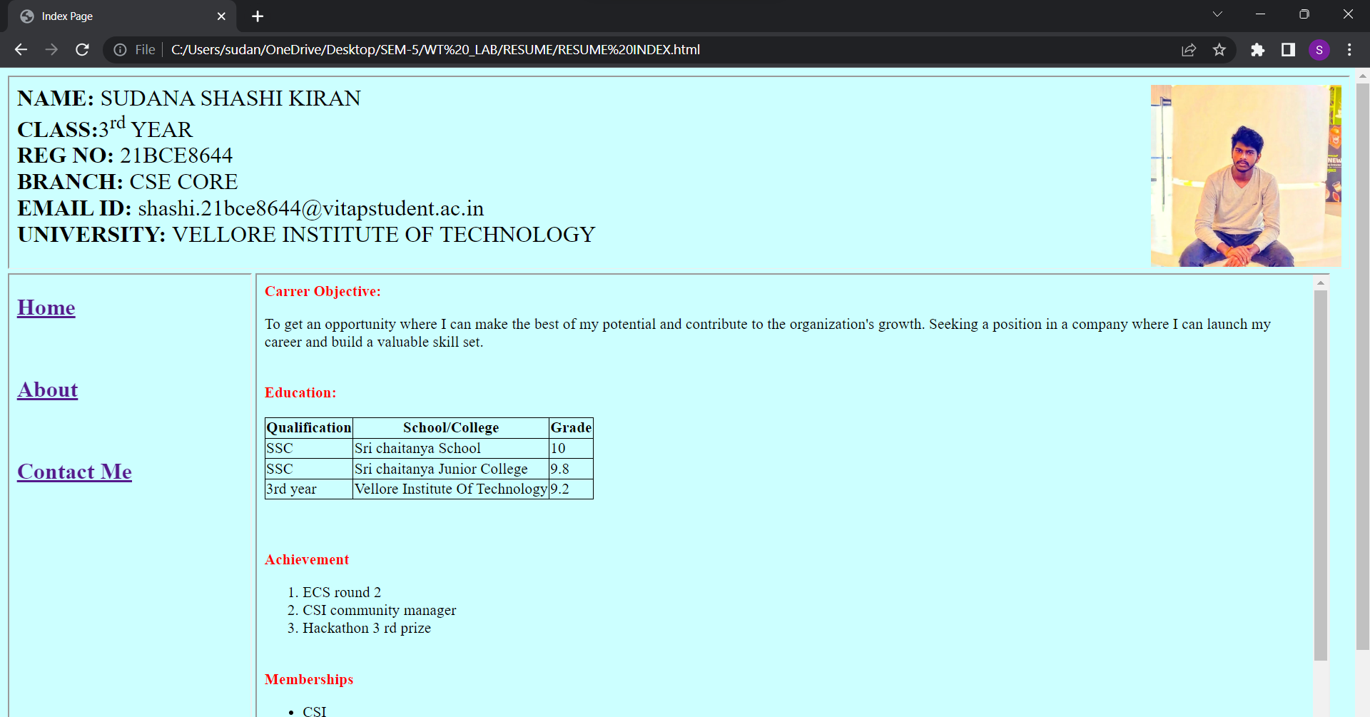

The continue-

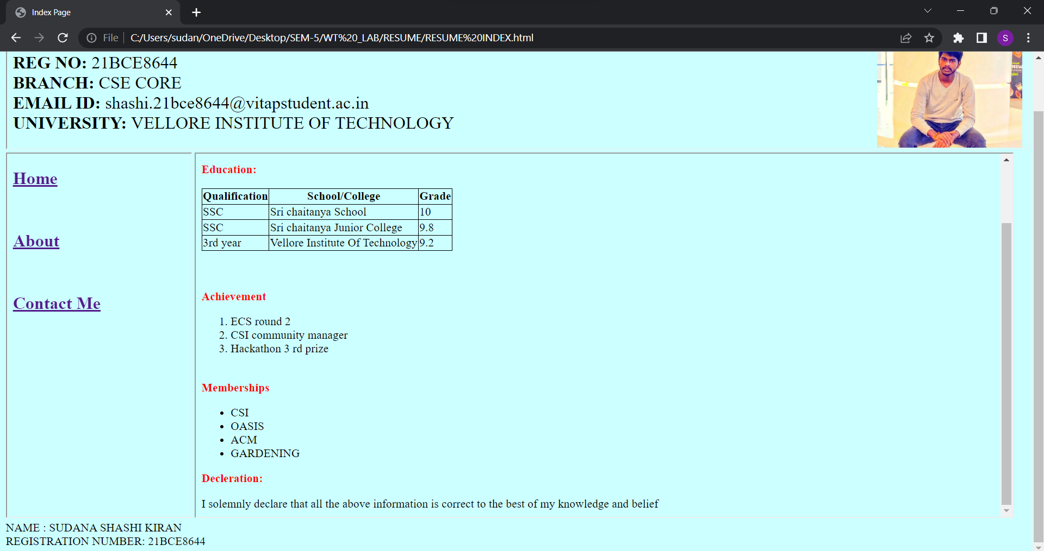

**For contact me hyper link :**

**Code:**

<!DOCTYPE HTML>

<html>

<head>

<title> Contact Page </title>

</head>

<body>

<center>

<h1>

SUDANA SHASHI KIRAN

21BCE8644

</h1>

<h2>

BTEC-CSE

</h2>

<h3>

E-MAIL:shashi.21bce8644@vitapstudent.ac.in </h3>

<h4>

MOBILE NUMBER:6309844325

</h4>

</body>

</html>

**Screenshot :**

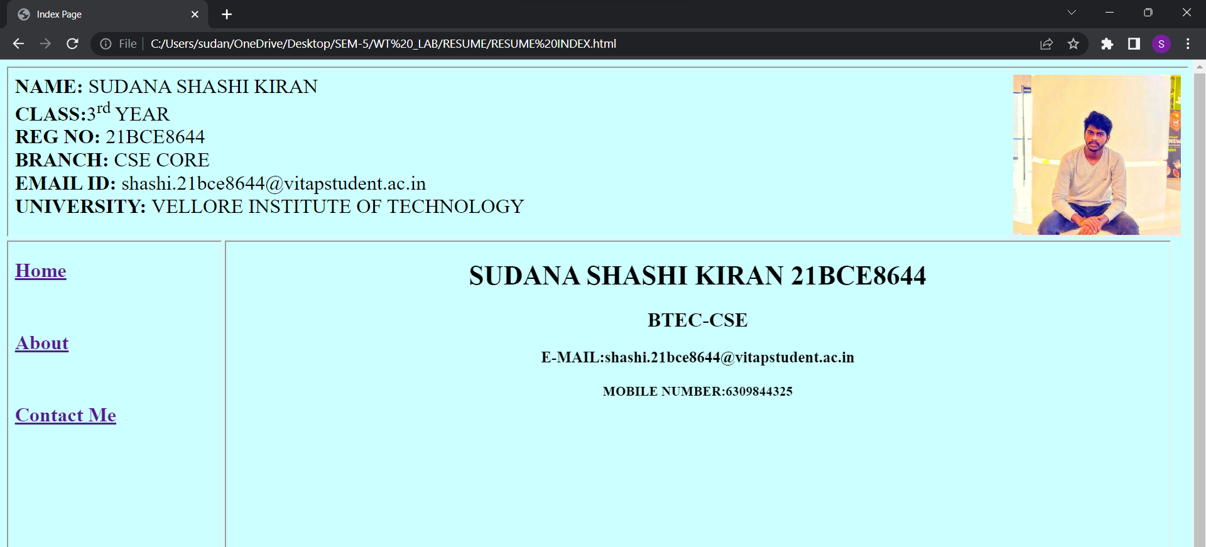

**THE OVERALL OUTPUTS OF THE RESUME :**

file:///C:/Users/sudan/OneDrive/Desktop/SEM-5/WT%20_LAB/RESUME/RESUME%20INDEX.html

Link of my resume

